**Level 1: PC Tower Case**

**Outline**

Learn about the internals of a standard PC case by examining physical samples and selecting and labeling images found on-line. Gain deeper knowledge by researching and reporting on specific components.

**Questions**

1. Find one (or more) images that clearly show the internals of a PC Tower Case.   
   (i.e. Google images using keywords “PC Case Internals”)

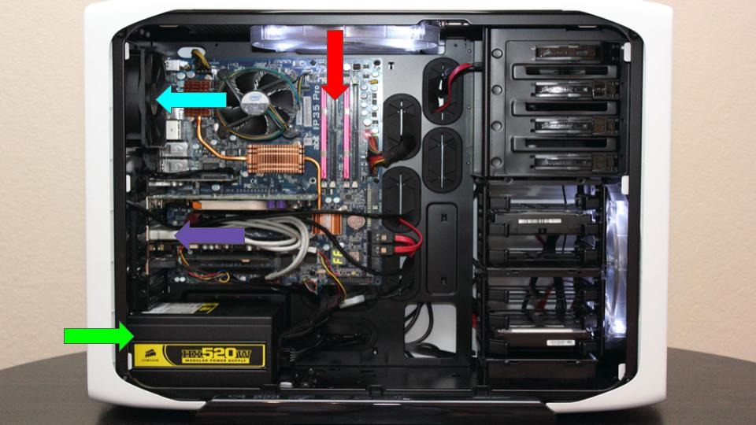

1. Clearly label the following components (using arrows) on your image of the PC case internals:
   1. Motherboard
   2. Power Supply
   3. Hard Disk Drive
   4. Optical Disk Drive (e.g.DVD)
   5. USB Expansion Ports
   6. Monitor Port
   7. Audio Ports
   8. Ethernet Port
   9. Cooling Fan
2. Research more in-depth about “Motherboards”. Make notes on the following:
   1. What different versions are currently available (speed and capacity)

AT Motherboards - 66 MHz to over 800 MHz  
ATX Motherboards -   
Expansion Slots - (A, 133 MB/s) (B, 20 MB/s) (C, 500 MB/s) (D, 500 GB/s)  
RAM(memory) slots - four 4GB sticks or two 8GB sticks to reach your maximum  
CPU Socket - 72GB capacity has 36GB per CPU SLOT capacity  
BIOS - Full capacity of PATA (EIDE) drives larger than 137GB (128 GB binary)  
CMOS Battery - This cell battery has an estimated life of 3 years when power supply unit (PSU) is unplugged or when the PSU power switch is turned off.  
Power Connectors - supply provides a number of peripheral power connectors and (in modern systems) two connectors for the motherboard

* 1. How the component has changed since the 1980’s

Personal computer motherboards began to include single ICs capable of supporting a set of low-speed peripherals, keyboard, mouse, floppy disk drive, serial ports, and parallel ports. By the late 1990s, many personal computer motherboards included consumer-grade embedded audio, video, storage, and networking functions without the need for any expansion cards at all. Higher-end systems for 3D gaming and computer graphics typically retained only the graphics card as a separate component. Business PCs, workstations, and servers were more likely to need expansion cards, either for more robust functions, or for higher speeds. Those systems often had fewer embedded components.

1. Research more in-depth about “Hard Disk Drives”. Make notes on the following:
   1. What different versions are currently available (speed and capacity)
   2. How the component has changed since the 1980’s

**NOTE:**

* Download the on-line version of this module (from the class GitHub repository)
* Questions for Level 2 and Level 3 are in the on-line version of this module
* Provide your answers in a MS Word, PowerPoint, or equivalent format
* Upload your answers to your personal GitHub repository

**Level 2: PC Motherboard**

**Outline**

Learn about the structure of a standard PC motherboard by examining physical samples and selecting and labeling images found on-line. Gain deeper knowledge by researching and reporting on specific components.

**Questions**

1. Find one (or more) images that clearly show the layout of a PC Motherboard.   
   (i.e. Google images using keywords “PC Motherboard”)
2. Clearly label the following components (using arrows) on your image of the PC motherboard:
   1. CPU (and fan)
   2. RAM Memory
   3. Disk Drive Interface (IDE or SATA)
   4. GPU Graphics Processor (either on-board or Graphics Card)
   5. Sound Processor (either on-board or Sound Card)
   6. Wi-Fi / Ethernet Network Interface (either on-board or Graphics Card)

1. Research more in-depth about “CPU Processor Chip”. Make notes on the following:
   1. What different versions are currently available (speed and capacity)
   2. How the component has changed since the 1980’s
2. Research more in-depth about “RAM Memory”. Make notes on the following:
   1. What different versions are currently available (speed and capacity)
   2. How the component has changed since the 1980’s

**Level 3: Peripheral Devices**

**Outline**

Learn about how peripheral devices are connected to the back side of a typical PC tower case. Examine physical samples, select and labeling images found on-line and gain deeper knowledge by researching and reporting on specific components.

**Questions**

1. Find one (or more) images that clearly show the layout of the back of a typical PC tower case.   
   (i.e. Google images using keywords “Back Of PC Tower”)
2. Clearly label the following components (using arrows) on your image of the back of a typical PC tower case:
   1. Power cord and power switch
   2. Monitor Interface (VGA or DVI or HDMI)
   3. Mouse Interface (USB or PS/2)
   4. Keyboard Interface (USB or PS/2)
   5. USB Ports
   6. Audio Inputs / Outputs
   7. Ethernet Interface

1. Research more in-depth about “Monitor Technology”. Make notes on the following:
   1. What different versions are currently available (e.g. VGA / DVI, Flat Panel Technology))
   2. How the component has changed since the 1980’s (e.g. Display Resolution, Technology)
2. Research more in-depth about “External Portable Storage”. Make notes on the following:
   1. Floppy Disks
   2. CD-ROM / DVD / Recordable CD/DVD
   3. USB Memory Drives
   4. Compact Flash Memory
   5. Cloud Based Storage

**Level 4: PC Component Presentation**

**Outline**

Explore the development and features of a specific PC hardware component through deeper research and investigation. Work in partners to create a short presentation. Deliver the presentation to the class.

Each group will research a unique PC hardware component . Your specific topic will be assigned from the list provided below.

**Presentation Structure**

1. Explain what the PC component does and how it fits together with other components to make up a fully functioning PC.
2. Explain how the PC component works. Provide a diagram (image) showing the main parts of the component.
3. Research the current state of the art of the component in terms speed, capacity (size), and other related factors.
4. Research on-line suppliers that sell the PC Component. List the specifications for the available products and the cost (price).
5. Research how the PC component has changed and evolved since the early days of PCs in the 1980’s. Cover each of the following topics separately:
   1. Component Speed
   2. Component Size / Capacity
   3. Two other specifications specific to the PC component (ask Mr. Nestor)

**PC Component Topics**

|  |  |  |
| --- | --- | --- |
| **Topic** | **Partner 1** | **Partner 2** |
| CPU Microprocessor Chip |  |  |
| Motherboard Layout |  |  |
| Computer Graphics |  |  |
| Sound & Audio |  |  |
| Hard Disk Drives |  |  |
| Removable Disk Storage |  |  |
| Network / Internet Connectivity |  |  |
| Mouse / Pointing Devices |  |  |
| Monitor & Display Technology |  |  |
| Printers & Output Technology |  |  |